Experiment:15 Date:1/08/2027

To Implement the Naïve Bayes Algorithm

Aim:
To develop a Python program to implement the Naïve Bayes Algorithm for classifying data based on the training dataset and predicting the class label for a given test input.

Algorithm (Naïve Bayes):
- Read the number of training records.
- Read the feature values and class labels.
- Train the Naïve Bayes classifier.
- Read the test data from the user.
- Predict the class label using the trained model.
- Display the predicted class label.
Programs:
from sklearn.naive_bayes import GaussianNB
n = int(input("Enter Number of Training Records: "))

X = []
Y = []
print("\nEnter Training Data")
for i in range(n):
a = int(input("Feature 1: "))
b = int(input("Feature 2: "))
c = input("Class Label: ")
X.append([a, b])
Y.append(c)
model = GaussianNB()
model.fit(X, Y)
print("\nEnter Test Data")
t1 = int(input("Feature 1: "))
t2 = int(input("Feature 2: "))
result = model.predict([[t1, t2]])
print("\nPredicted Class =", result[0])
Output:
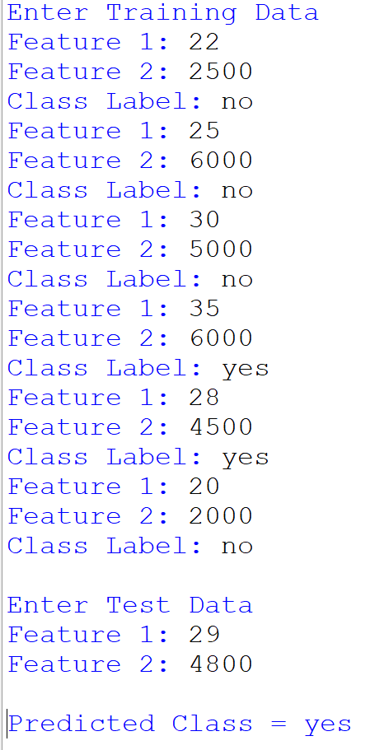

Result:Thus, the Naïve Bayes Algorithm was implemented successfully, and the class label for the given test data was predicted correctly.

